Service for Plough Sunday 8th January 2023 at 3pm
At Saint Nicolas Church Hail Weston
Zoom Id 418 405 5563 PW 022067
Or click here ZOOM LINK

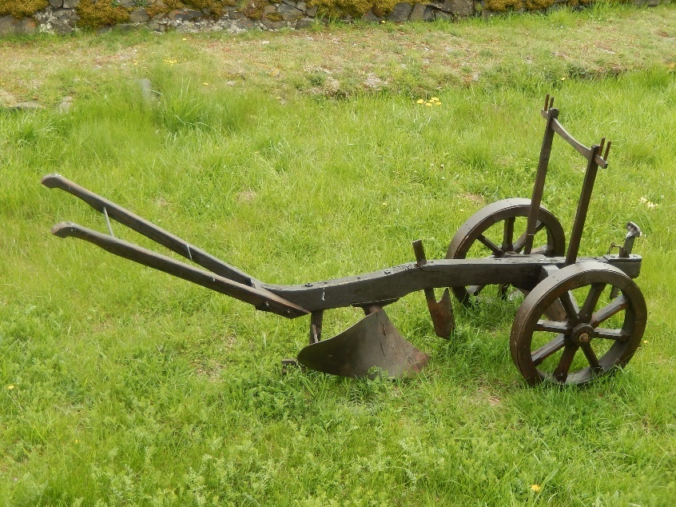

Welcome
Let us worship God: Father, Son and Holy Spirit.
All Amen
THE GATHERING
We are gathered together here to represent the farming communities of these Parishes of the Staughtons with Hail Weston. We are the carers of this land; the plough is the sign of all our labour in the countryside. Before the seed can be sown, before it starts to grow, before the corn can be reaped and before the bread is baked and the people fed we must plough the land.
Our Lord Jesus who walked with the farmers and the fishermen be with us now as we mark the beginning of a new year of farming.
All Be with us today as you were in ages past. Amen
Hymn: 272 Praise and thanksgiving
THE COLLECT
All Amen
OUR DEPENDENCE ON GOD
All Almighty God, with whom we can do everything,
Without whom we can do nothing:
Open our eyes that we may see you:
Open our lips that we may praise you:
Open our hearts that we may know you:
Through Jesus Christ our Lord. Amen.
We come together in the name of Christ to offer our praise and thanksgiving, to hear and receive God’s Holy Word, to pray for the farms in this community who work whatever the weather and whatever the day or the hour that they may prosper and be fruitful in their labours.
All Amen
CONFESSION (we say sorry) Sit or kneel

A farmer or another: When we are ungrateful for the rain, the sun the snow and the frost in their season.
All And forget they are God’s gift to us:
A farmer or another: When we are blind to the mystery of germination
All And forget it is God’s handiwork:
A farmer or another: When we are careless with the beasts
All And forget they are God’s creatures:
A farmer or another: When we are unkind to other people
All And forget they are God’s Children:
A farmer or another: When we are lazy in our work
All And forget we are God’s workers:
A farmer or another: When we ill-treat the land
All And forget it is God’s splendour:
O God forgive us.
May the Father of all mercies cleanse us from our sins and restore us in his image to the praise and glory of his name, through Jesus Christ our Lord.
All Amen.
Hymn:275 We plough the fields and scatter (during which the plough is brought forward)
Reading 1. Abundant growth through God’s providence Psalm 65:9-13
Blessing of the plough
O God our Father, giver of seedtime and harvest, bless all ploughs, tractors and tools, large and small, used in the work of our farms. May they be instruments of fruitfulness; may all who use them do so to your glory and in the grateful and hopeful offering of their daily work, for their own and others’ good, that your people may be fed and all rejoice in your bounty, through Jesus Christ our Lord.
All Amen.
God speed the plough
All God speed the plough.
(A shepherd’s crook is brought forward)
Reading 2. Growth through proper husbandry and care John 10:1-9

Blessing of the shepherd’s crook
O God, loving creator of all life, you call us to be grateful stewards of your creatures. Bless the cattle and horses, the pigs and sheep and poultry and all the animals we tend in your name and strengthen us with wisdom and compassion to care for them as you would have us do, to the glory of your name; through Jesus Christ our Lord.
All Amen
God guard the animals
All God guard the animals
(Some grain, soil and water is brought forward)
Reading 3. From bad growth to good Matthew 13:1-9

Blessing of the soil, seed and water
Blessed are you, Lord of creation, this soil, seed and water are the gifts of your hand, signs of your generous love and the miracle of new life and growth. Bless all soil and all seed and the water that falls upon them, that the potential they hold will ensure all may have plenty and be filled.

All Amen

God bless the soil, the seed and the water
All God bless the soil, the seed and the water

Hymn: 270 Come ye thankful people come
TALK

PRAYERS Please sit or kneel

Let us pray
All: Our Father who art in heaven
Through our love of the countryside,
Through our care for animals,
Through our respect for property and tools,
All: Hallowed be thy name,
On our farms and in our homes,
In our training colleges and schools,
Where machinery is made, and where policy is planned,
All: thy Kingdom come
By our seeking your guidance,
By our keeping your commandments,
By our living true to our consciences,
All: Thy will be done on earth as it is in heaven
For the millions who live in poverty and hunger,
For our own needs, and the requirements of our neighbours,
By co-operation, sympathy, and generosity,
All: Give us this day our daily bread
Because we have broken your commandments, doing what we ought not to do, and neglecting what we ought to do,
All: Forgive us our trespasses
If any have injured us by injustice, double dealing or exploitation,
All: as we forgive those who sin against us
When we consider doing to others what we would dislike done to us, or when prosperity lulls us to false security, or adversity prompts us to despair, or when success makes us boastful, or failure makes us bitter,
All: Lead us not into temptation but deliver us from evil
In the assurance of faith,In the confidence of hope,In the will to serve, help us to love Christ as Lord, and our neighbours as ourselves.
All: For thine is the Kingdom the power and the glory for ever and ever. Amen.

Offertory Hymn: 253 For the beauty of the earth

THE BLESSING:
Go in peace to love and serve the Lord
All In the name of Christ. Amen

Notices:
If you are able to offer your farm for the annual Rogation walk which is usually in May please let Rev. Nicki (01480 869485) or Glenn (07854 673771) know.
Thank you

Please donate to St. Nicolas Church here, Thank you

