Rogationtide Service

14th May 2023 3pm

Wood Farm in Hail Weston

Picture of Wood Farm ancient wood, Hail Weston

Thanks to Rob and Anne-Marie Hamilton for hosting this year’s Walk and Talk.

**In aid of St.Nicolas restoration fund**

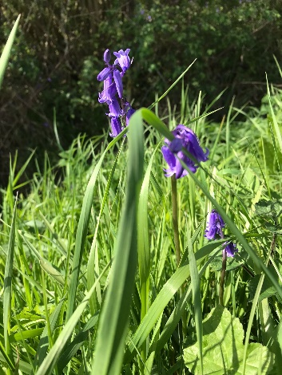

We begin at Wood Farm Hail Weston

Rob and Anne-Marie offer a warm welcome to you all.

**Opening sentences**

O taste and see that the Lord is good; happy are those who take refuge in him.

You cause the grass to grow for the cattle and plants for the people to use, to bring forth food from the earth, and wine to gladden the human heart, oil to make the face shine and bread to strengthen the human heart.

(Psalm 34 v 8 and Psalm 104 v 14ff)

**The Collect**

Almighty God, Whose Son Jesus Christ ate with sinners and shared the bread of life with his disciples on the night he was betrayed; we give you thanks for the gift of food which gives physical and spiritual nourishment. Bless the labours of those who work to grow, produce, distribute, sell and fashion our food. Bless the increase of crops and animals that your food may be shared and enjoyed by all your people; through Jesus Christ our Lord. Amen.

We walk to the animals

**Hymn**

1 Morning has broken like the first morning;

blackbird has spoken like the first bird.

Praise for the singing! Praise for the morning!

Praise for them, springing fresh from the Word!

2 Sweet the rain’s new fall, sunlit from heaven,

like the first dew-fall on the first grass.

Praise for the sweetness of the wet garden,

sprung from completeness where his feet pass.

3 Mine is the sunlight! Mine is the morning

born of the one light Eden saw play!

Praise with elation, praise every morning,

God’s re-creation of the new day!

# **Reading: Genesis 1:26-28**

Then God said, “Let us make mankind in our image, in our likeness, so that they may rule over the fish in the sea and the birds in the sky, over the livestock and all the wild animals, and over all the creatures that move along the ground.”

So, God created mankind in his own image, in the image of God he created them; male and female he created them.

God blessed them and said to them, “Be fruitful and increase in number; fill the earth and subdue it. Rule over the fish in the sea and the birds in the sky and over every living creature that moves on the ground.”

Talk about Sheep – Rob Hamilton

Prayer for livestock

We thank you for the farm animals and those farmers who look after them, In Your infinite wisdom, Lord God, when You created the universe, you blessed us with all living creatures. We especially thank you for giving us our farm animals who are so important to our lives. May we realize that as our animals trust us to take care of them, so we should trust You to take care of us, and in taking care of them we share in Your love for all creatures.

In Jesus’ name

Amen

We walk onwards to the fields

**Hymn**



[This Photo](http://www.baby-flash.com/wordpress/2015/04/23/sequenze-di-azioni-quotidiane/) by Unknown Author is licensed under [CC BY-NC-ND](https://creativecommons.org/licenses/by-nc-nd/3.0/)

1 We plough the fields and scatter  
the good seed on the land,  
but it is fed and watered  
by God's almighty hand.  
He sends the snow in winter,  
the warmth to swell the grain,  
the breezes and the sunshine,  
and soft refreshing rain.

(Refrain)   
All good gifts around us  
are sent from heaven above;  
then thank the Lord, O thank the Lord  
for all his love.

2 He only is the Maker  
of all things near and far;  
he paints the wayside flower,  
he lights the evening star;  
the wind and waves obey him,  
by him the birds are fed;  
much more to us, his children,  
he gives our daily bread. [Refrain]

3 We thank you, then, O Father,  
for all things bright and good:  
the seed-time and the harvest,  
our life, our health, our food;  
no gifts have we to offer  
for all your love imparts,  
but that which you desire now:  
our humble, thankful hearts! [Refrain]

**Reading Luke 12: 22-27**

He said to his disciples, “Therefore I tell you, do not worry about your life, what you will eat, or about your body, what you will wear.  For life is more than food, and the body more than clothing. Consider the ravens: they neither sow nor reap, they have neither storehouse nor barn, and yet God feeds them. Of how much more value are you than the birds! And can any of you by worrying add a single hour to your span of life? If then you are not able to do so small a thing as that, why do you worry about the rest? Consider the lilies, how they grow: they neither toil nor spin, yet I tell you, even Solomon in all his glory was not clothed like one of these.

Talk about the fields and crops – Rob Hamilton

Prayer for the Countryside

Loving God, who has made everything. We thank you for this beautiful countryside and for our freedom to enjoy it. We thank you for the seasons which dress the land in white in winter and green in summer, for birds nesting in springtime and the golden fields of the autumn harvest. We thank you for the farm animals and those farmers who look after them, for the good earth and the care that farmers take to grow our food.

There are many pressures on the environment, from climate change which threatens so many, to falling populations of our wild creatures.

Help us all to look after your gift of the countryside. Bless the work of farmers in the local community who carry responsibility for so many environmental improvements on our behalf, so that the countryside is preserved for this generation and for all generations to come. Amen

We walk to the water

**Hymn**

*(Refrain)*  *All things bright and beautiful,   
all creatures great and small,   
all things wise and wonderful,   
the Lord God made them all*



[This Photo](http://www.baby-flash.com/wordpress/2015/04/23/sequenze-di-azioni-quotidiane/) by Unknown Author is licensed under [CC BY-NC-ND](https://creativecommons.org/licenses/by-nc-nd/3.0/)

1 Each little flower that opens,   
each little bird that sings,   
He made their glowing colours,   
He made their tiny wings. [Refrain]

2 The purple-headed mountain,   
the river running by,   
the sunset and the morning   
that brightens up the sky. [Refrain]

3 The cold wind in the winter,   
the pleasant summer sun,   
the ripe fruits in the garden:   
He made them every one. [Refrain]

4 He gave us eyes to see them,   
and lips that we might tell

How great is god Almighty

Who has made all things well. [Refrain]

**Reading: Exodus 17: 1 – 7**

From the wilderness of Sin the whole congregation of the Israelites journeyed by stages, as the Lord commanded. They camped at Rephidim, but there was no water for the people to drink. The people quarrelled with Moses, and said, “Give us water to drink.” Moses said to them, “Why do you quarrel with me? Why do you test the Lord?”  But the people thirsted there for water; and the people complained against Moses and said, “Why did you bring us out of Egypt, to kill us and our children and livestock with thirst?”  So Moses cried out to the Lord, “What shall I do with this people? They are almost ready to stone me.”  The Lord said to Moses, “Go on ahead of the people, and take some of the elders of Israel with you; take in your hand the staff with which you struck the Nile, and go.  I will be standing there in front of you on the rock at Horeb. Strike the rock, and water will come out of it, so that the people may drink.” Moses did so, in the sight of the elders of Israel.  He called the place Massah and Meribah, because the Israelites quarrelled and tested the Lord, saying, “Is the Lord among us or not?”

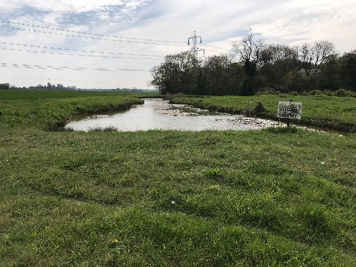

Talk about Wood Farm’s water supply – Rob Hamilton

Prayer for water

Thank you for water;  
for its smooth cleanness as it runs from our taps,  
water that is safe for drinking, water that doesn’t stop running. Thank you for the lakes around us, for the chortling of streams, for the rushing of rivers, for the richness of water resources. Thank you for water from the skies, for water that falls on gardens and crops fuelling green growth and food for the world.  
  
Water is so ever present, so powerful and lifegiving,  
we almost forget that it is a gift from you.  
Thank you for placing us as your children  
in the water-rich world.

Today we pray for dry places in the world;  
for lands where people walk long distances for water.  
Lord, give us a thirst for righteousness and justice!  
Help us work for peace in our world,  
for there is so much water and yet many are thirsty.  
We pray all this in Jesus’ name,  
who is Living Water for us all,  Amen.

We walk back towards the Farmhouse stopping near the orchard

Our Local Communities

Hail Weston

Talk about St.Nicolas Hail Weston and the plans to re-order and improve the Church for the local community.

Anne-Marie Hamilton MBE.

Please stay after the service for teas, coffee and a slice of cake.

All donations will go to St.Nicolas restoration fund.

Prayer for our Local Communities

Almighty God who is among us always, we thank you for the communities we have around us. All churches in these parishes, and for all the activities organised by local groups for the benefit of these villages which knit our rural communities together and sustain our way of life.

We pray for the farming community who cannot take time off sick easily and who’s deadlines are prescribed by the seasons.

We ask for your blessing on our local communities and all they do and that their activities will be pleasing in your sight producing a fruitful harvest year by year. Amen

Blessing



[This Photo](http://kewl-beans.blogspot.com/2011_04_03_archive.html) by Unknown Author is licensed under [CC BY-NC-ND](https://creativecommons.org/licenses/by-nc-nd/3.0/)

May God the Father of our Lord Jesus Christ, who is the source of all goodness and growth, pour out his blessing upon all things created and upon you his children, that we may use his gifts to his Glory and the welfare of all people. And the blessing of God Almighty, the Father, the Son and the Holy Spirit, be among you and remain with you always.

**All: Amen**

***Minister***: Go in peace to love and serve the Lord.

**All: In the name of Christ. Amen**

*Rogationtide*

*This was traditionally a time when Christians prayed for God’s blessings on their crops and other aspects of their work on the land. A service was followed by a visit to various places in the neighbourhood. Often this was combined with ‘Beating the Bounds’, a very old custom from a time when it was important to know the boundaries of the parish.*