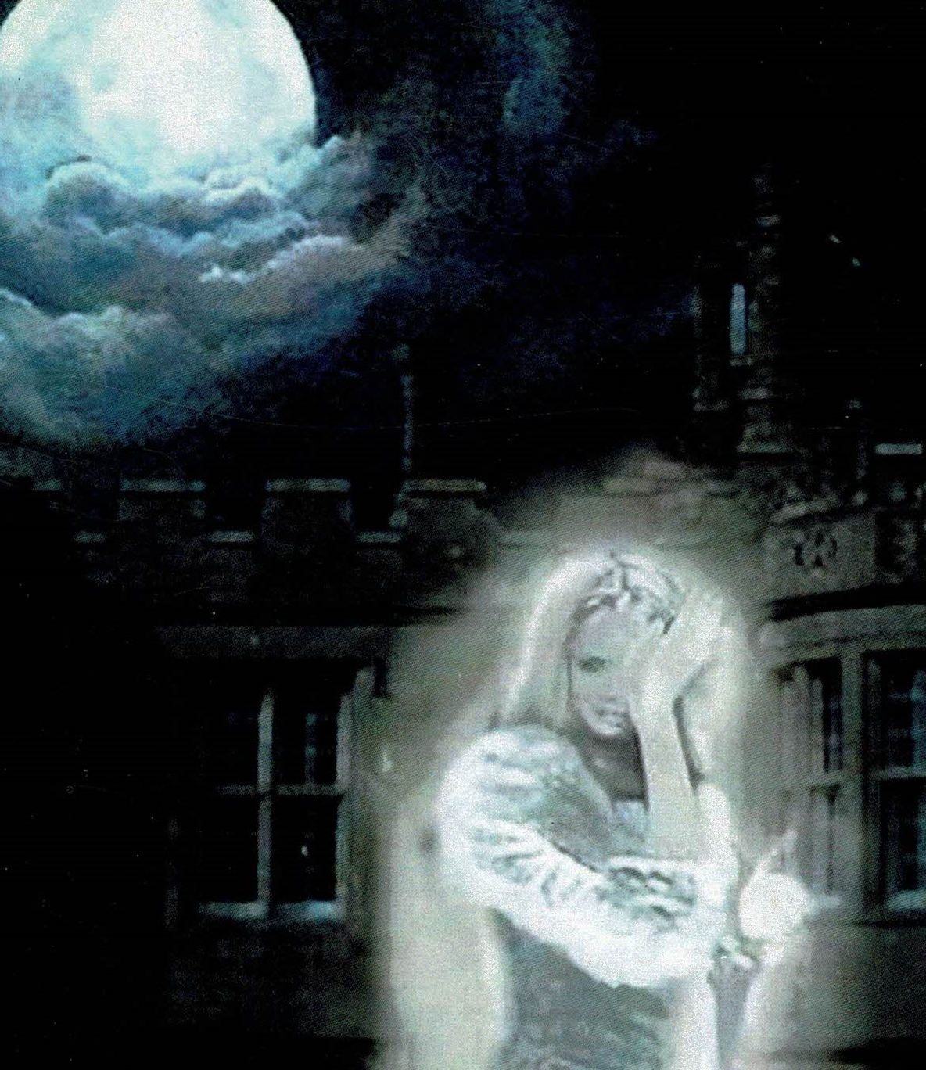
ST NICOLAS CHURCH RESTORATION GROUP
Requests the pleasure of your company

‘ROYALS AND REGALS’
AN ILLUSTRTED TALK BY

MARK EGERTON
(Author of The Haunted History of Huntingdonshire)

Friday, 26th January 2024

St Nicolas Church, Hail Weston, PE19 5JS

7.00 p.m. for 7.15 p.m. start

Copies of ‘Haunted Huntingdonshire’ will be available on the night at £24.99 each

Tickets £12.50 (including a glass of wine) available from:
- Anne-Marie Hamilton – 01480 212772
- Mary Deacon – 01480 812363

Raffle

All proceeds towards the St Nicolas Church Restoration

